Experiment 12:
CHANGE HARDWARE COMPATIBILITY OF A VM (EITHER BY CLONE/CREATE NEW ONE) WHICH IS ALREADY CREATED AND CONFIGURED.

STEP 1
Registration
While registering …give saveethamail id and password don’t repeat mail id characters …give engineer as job title …give strong password and click … “I want to build my profile”
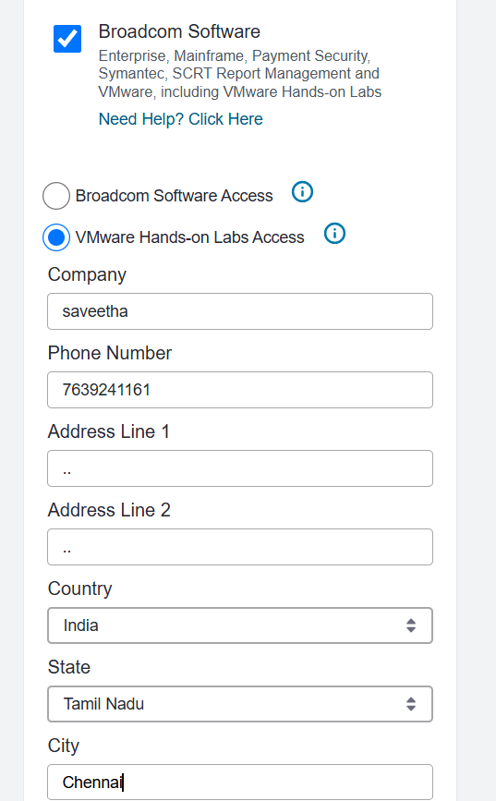
After this click submit and the account registration gets completed

https://support.broadcom.com/group/ecx/productdownloads?subfamily=VMware+Workstation+Pro&freeDownloads=true&utm
GO TO THIS WEBSITE ..RIGHT CORNER …CLICK LOGIN AND ENTER UR USERNAME AND PASSWORD CORRECTLY …AFTER LOGIN IT LOOKS LIKE BELOW IMAGE
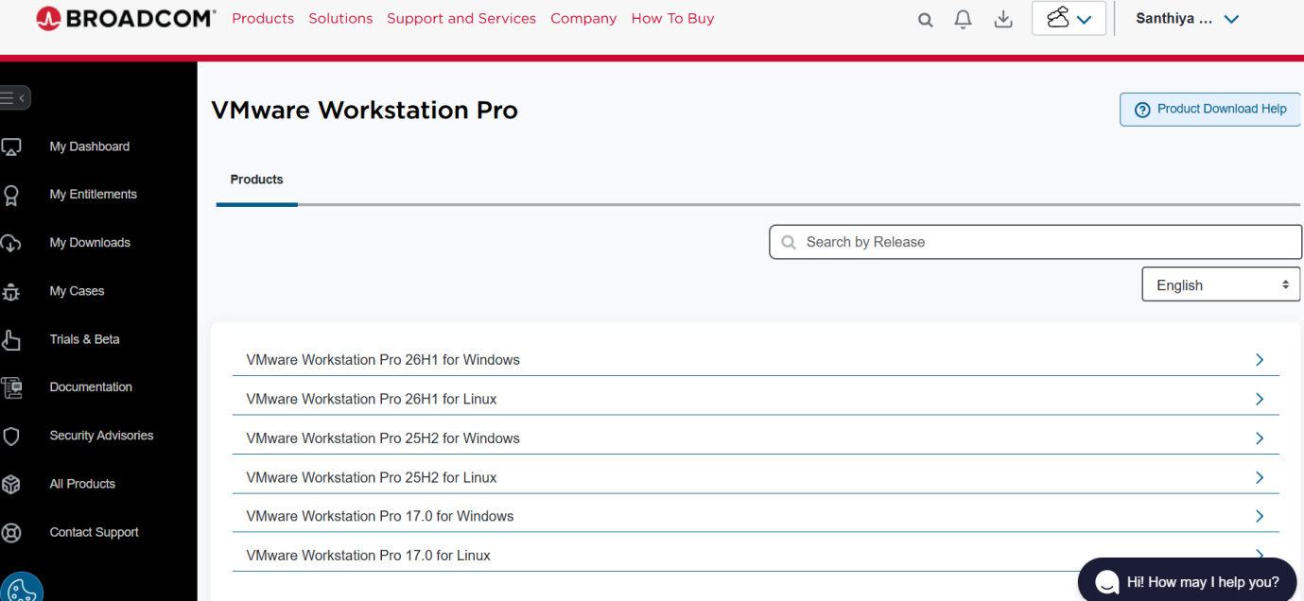
CLICK 26H1 FOR WINDOWS …CLICK TERMS AND CONDITION …OPEN that document and come back and check the box …again scroll right and find the download symbol and download the software.
Go to downloads in your laptop and after agreeing the licence agreement …give 2 times next and finaly finish installing it .
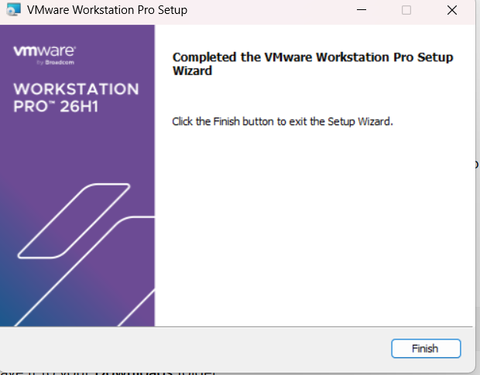

STEP 2
Now open vm ware in ur search box and after opening ..click create a new virtual machine, click next as below
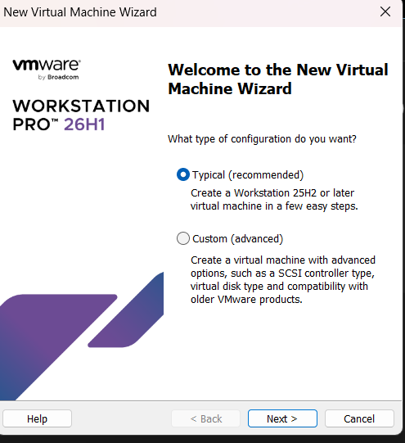
- After clicking NEXT Check the box …I will install the operating system later
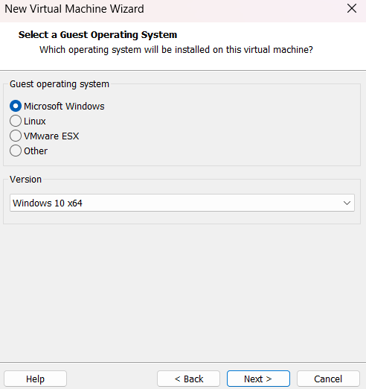
- After clicking NEXT Change VM Name into Windows_HW_Compatibility
- Change maximum disk size into 40 and click next and then give finish.
After clicking finish ..u ll get this below screen ..in that the state should be power off …don’t turn power on
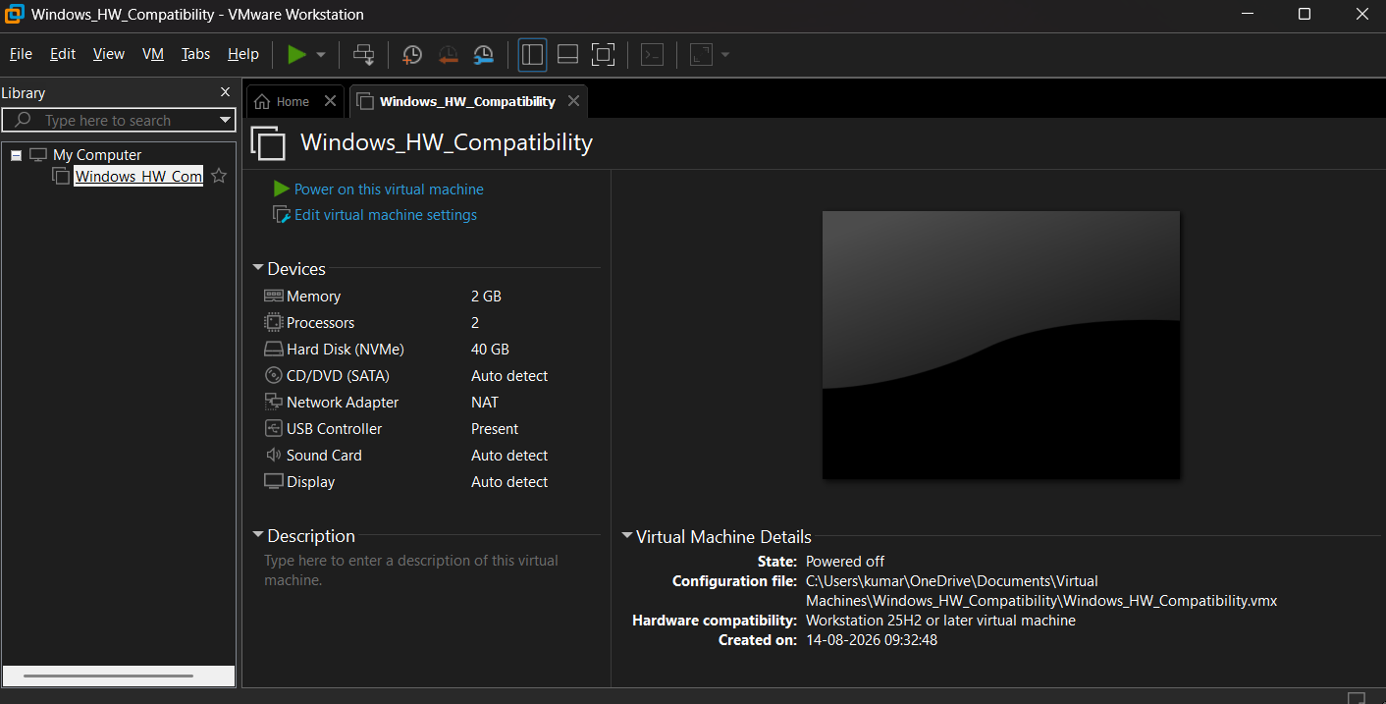
Rightclick windows compatability, click manage,click change hardware compatablity,click next
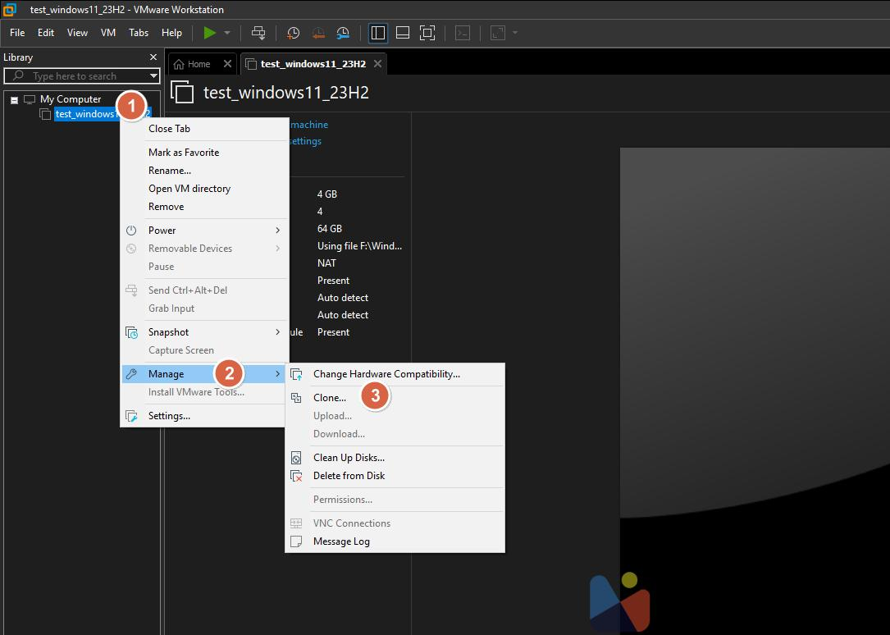
Change the workstation into 16.2.x like below and then click next
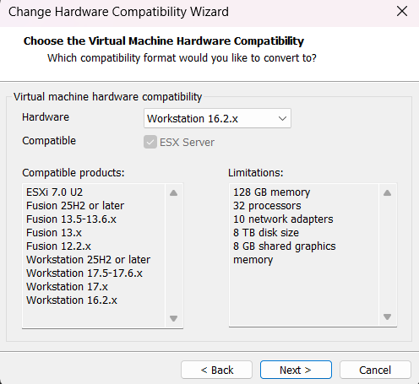
Check the box “After this virtual machine” and finish it
Again right click windows HW Compatability in library (leftside) select manage and select clone
Click the current state in vm
Create a full clone and click finish
After completion, your Library should contain something like:
My Computer

├── Windows_HW_Compatibility
│
└── Windows_HW_Compatibility_Clone
Experiment 13:
DEMONSTRATE INFRASTRUCTURE AS A SERVICE (IAAS) BY CREATING A VIRTUAL MACHINE USING A PUBLIC CLOUD SERVICE PROVIDER (AZURE), CONFIGURE WITH REQUIRED MEMORY AND CPU.

Create Microsoft azure account ..using this link ..
https://portal.azure.com
u ll get this below screen
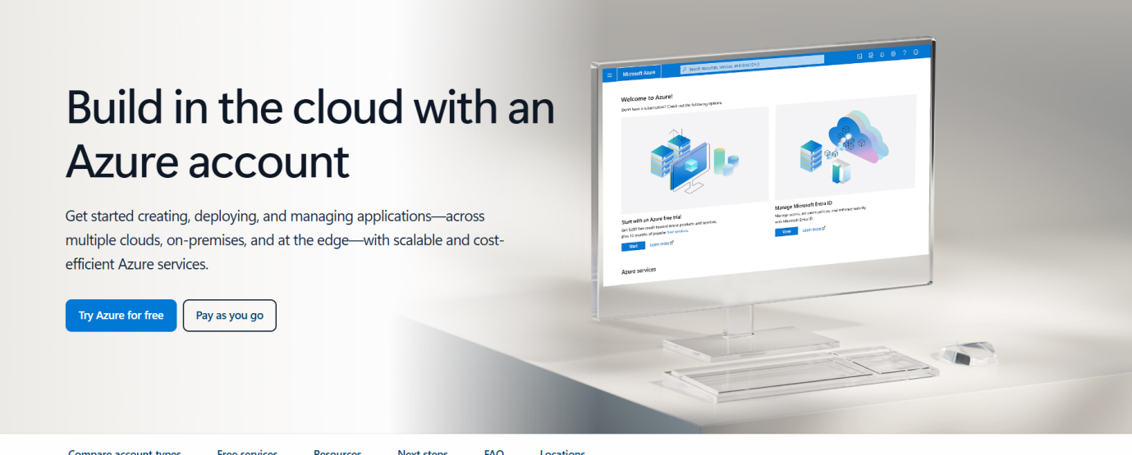

MOST IMPORTANT : “CLICK TRY AZURE FOR FREE DON’T CLICK PAY AS YOU GO ”
While clicking free option …to sign in and for verification purpose it ll ask your card details with cvv give it and enter otp ….note it s just for verification …u ll get 30 days free trail and after that u can delete the account …only two rupees ll b debited from ur account …it s mandatory for rest of ur lab experiments handson ..so do it
After signin search resource group n search bar then give create and u ll find below screen n that give name as IaaS-Lab-RG and change region to india south central

Step 1 create resorce grp
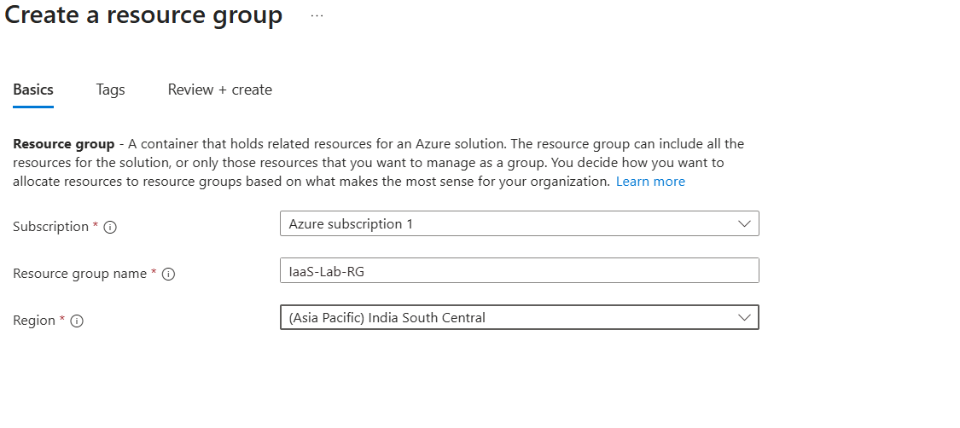
Then click:
Review + create → Create
Then resource grp created

Step 2 create virtual grp
In the Azure search bar, type:
Virtual networks
Select Virtual networks.
Click:
+ Create and give Virtual network name: as IaaS-Lab-VNet
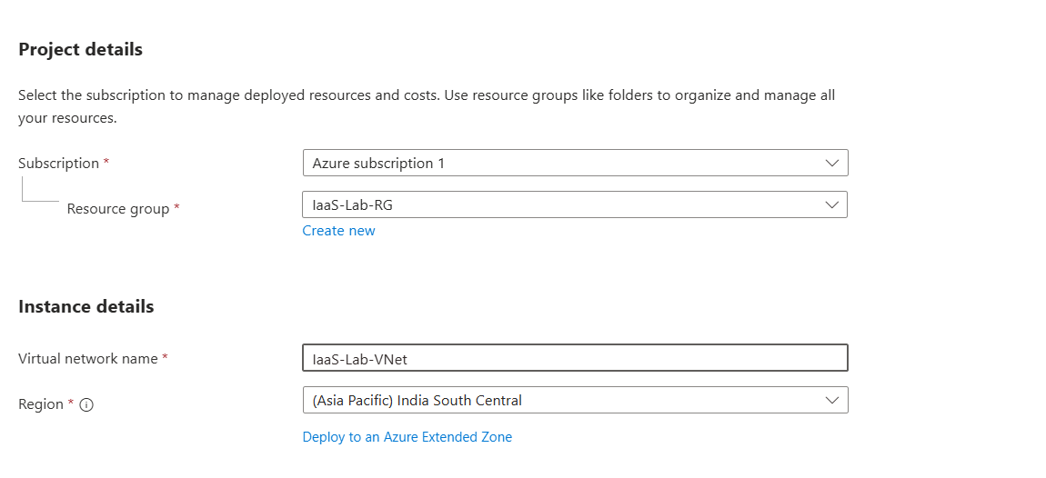
Don’t click next …click review and create and click create
So virtual grp created after doing this ..u ll get like below image
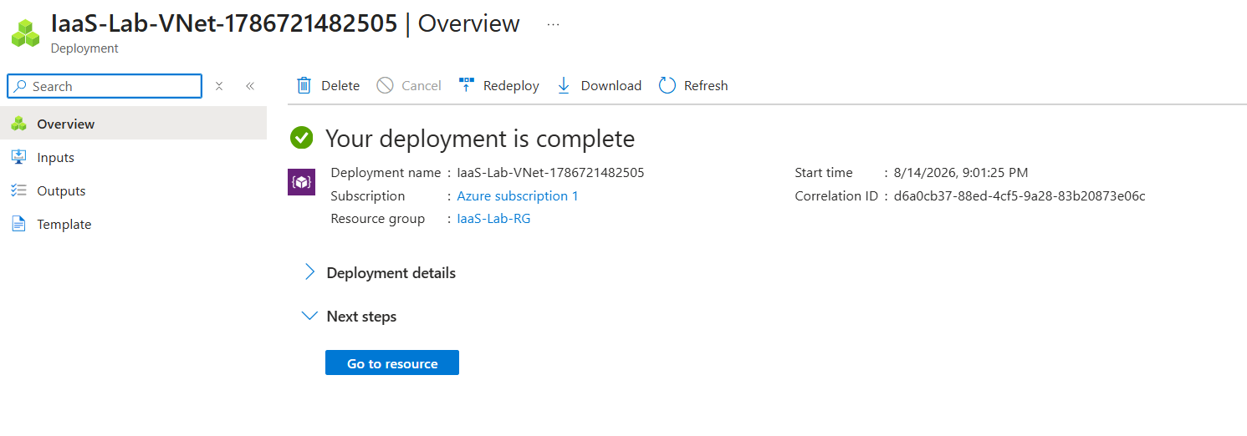
Step 3 Azure Virtual Machine
n search bar type virtual machine> create>select resource grp from drop down and enter virtual grp IaaS-Lab-VNet and change image and size like below picture
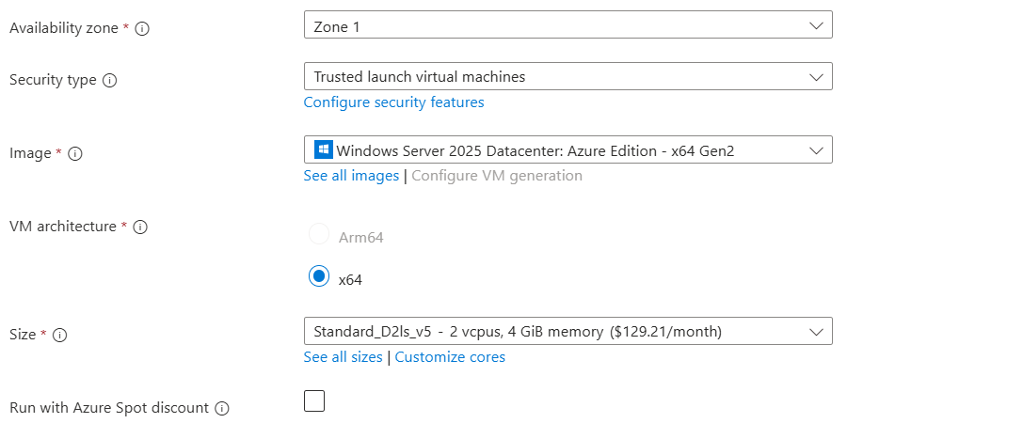

U can select the option which I have given from the list for both image and size
Then scroll down give password, select rdp from inbound ports and click..review and create > create
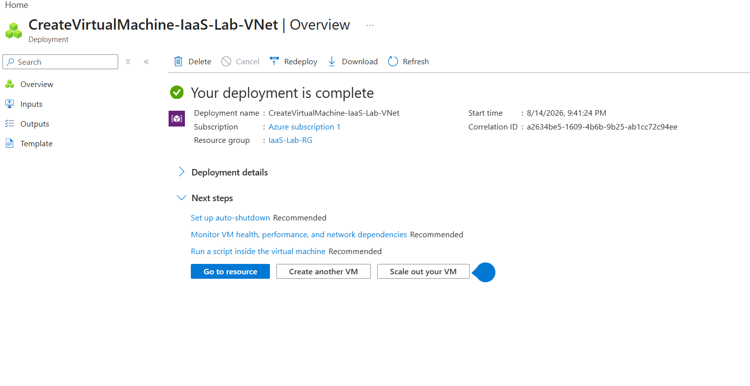
And u have created virtual machine i.e Successfully Deployed Azure Virtual Machine

Step 4 Connect Using RDP
Search bar ..type virtual machine> click ur virtual machine>click connect
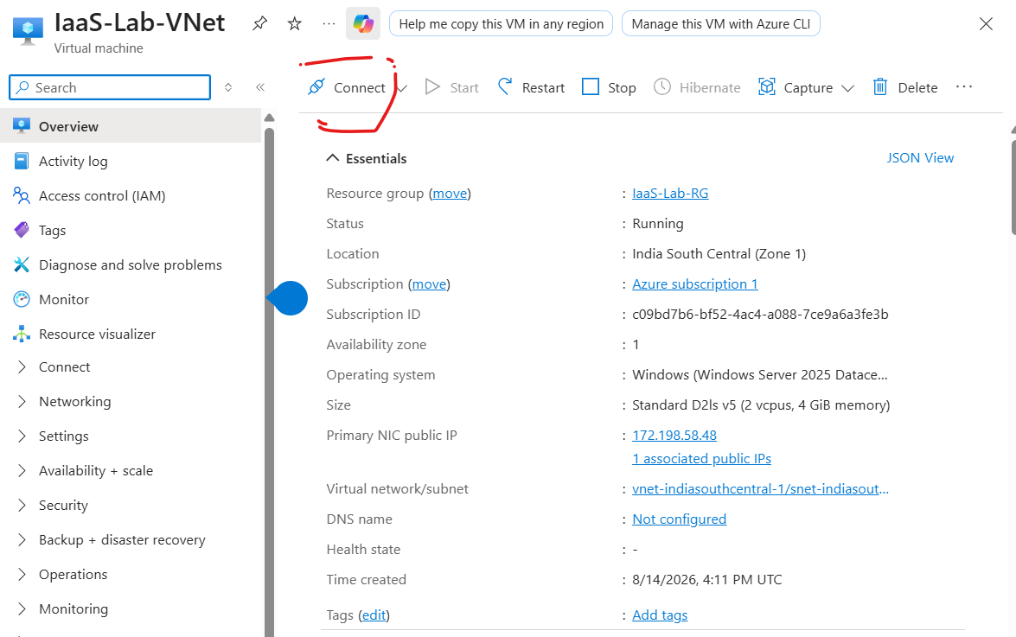
After connect click download rdp file …
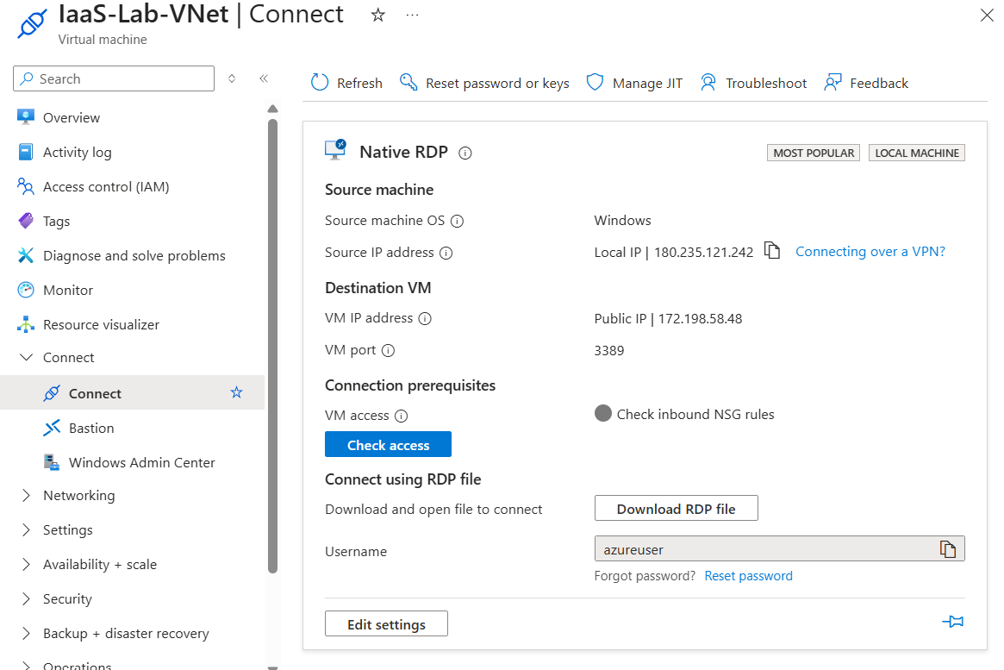
In download section double click the rdp file >click connect>enter password>click yes and finally the local server gets created…find the below images for reference
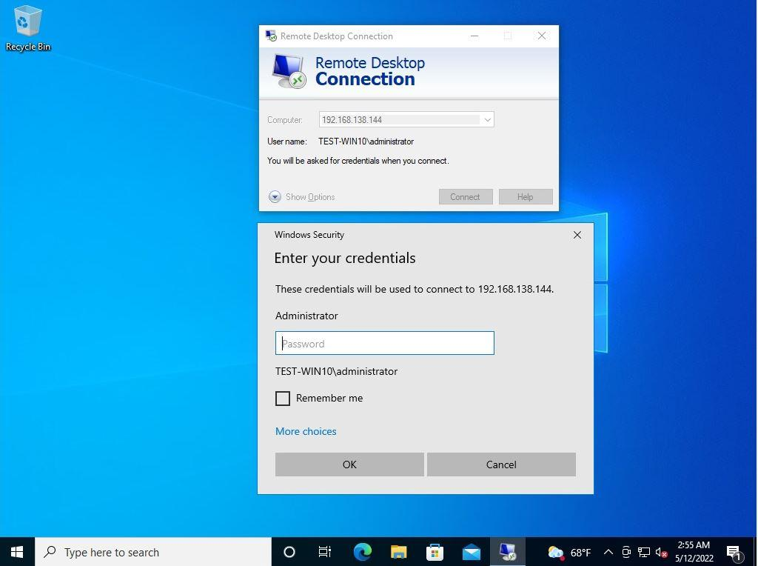
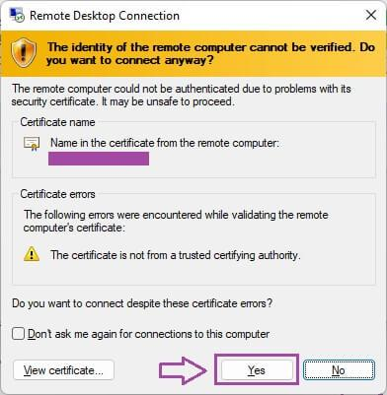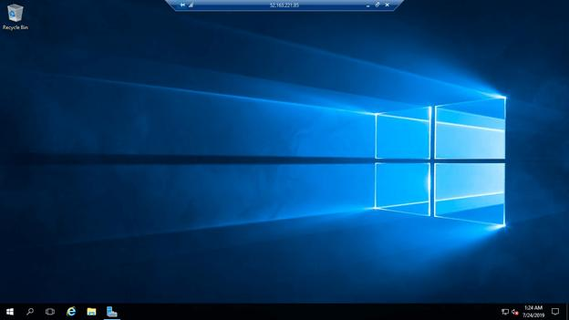

Step 5 resize vm
Search bar type vm…scroll;l down note the size as below

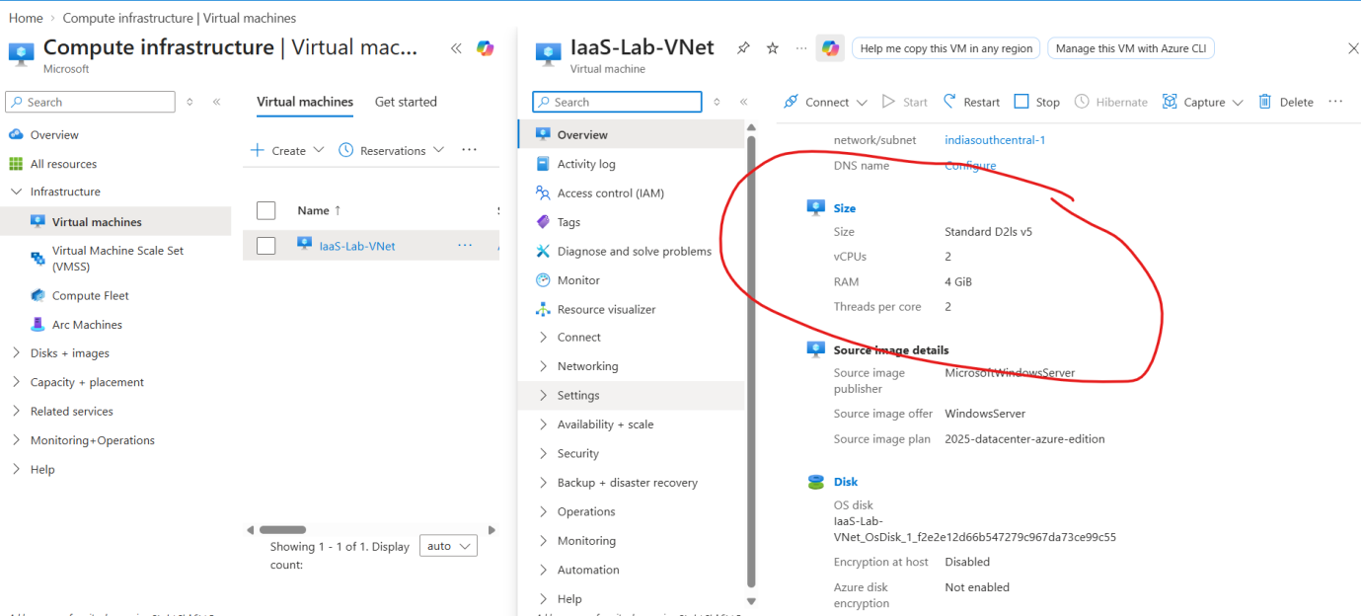

Step 6 stop the vm..near to restart

Step 7 change size ..in left side click availability and scaling and change the size from original …take before and after size screenshot …which s the output.

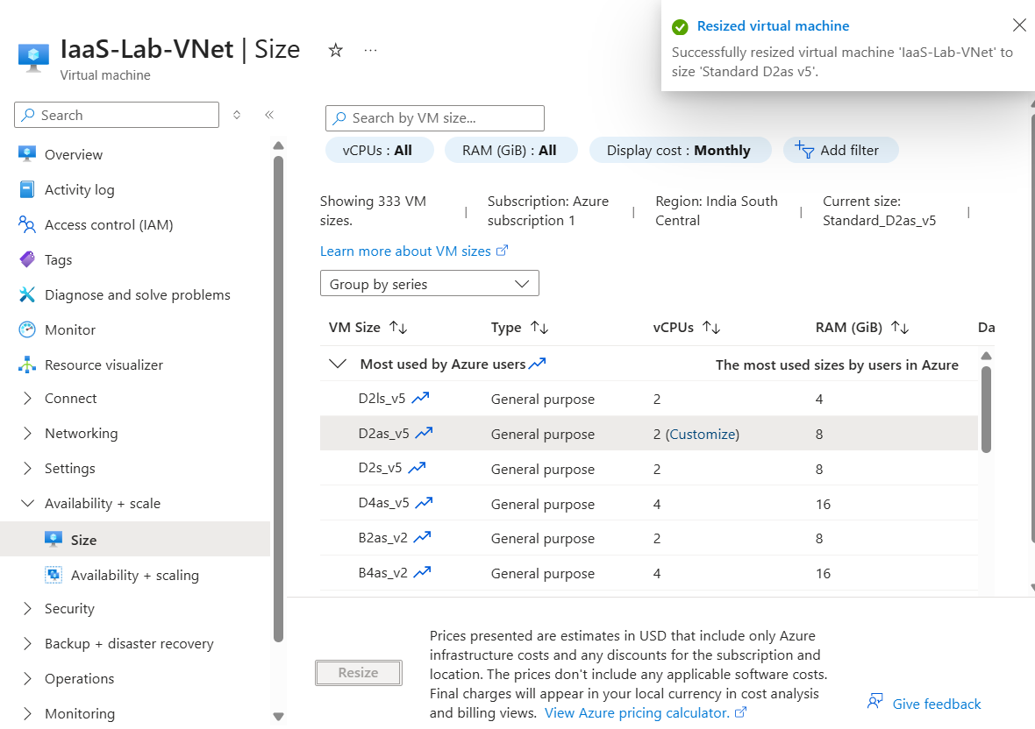

EXPERIMENT 15 : CREATE A SIMPLE WEB SITE USING ANY PUBLIC CLOUD SERVICE PROVIDER (AZURE/GCP/AWS) AND CHECK THE PUBLIC ACCESSIBILITY OF THE STORED FILE TO DEMONSTRATE STORAGE AS A SERVICE

Step 1 search app services>click app service>click create>web app>give resource name as the name wat I gave n below screenshot>instance details give the name as I gave but change last 123 to someother 3 digits number>select python 3.11>then central > scroll down>select pricing plan as free f1>click review and create

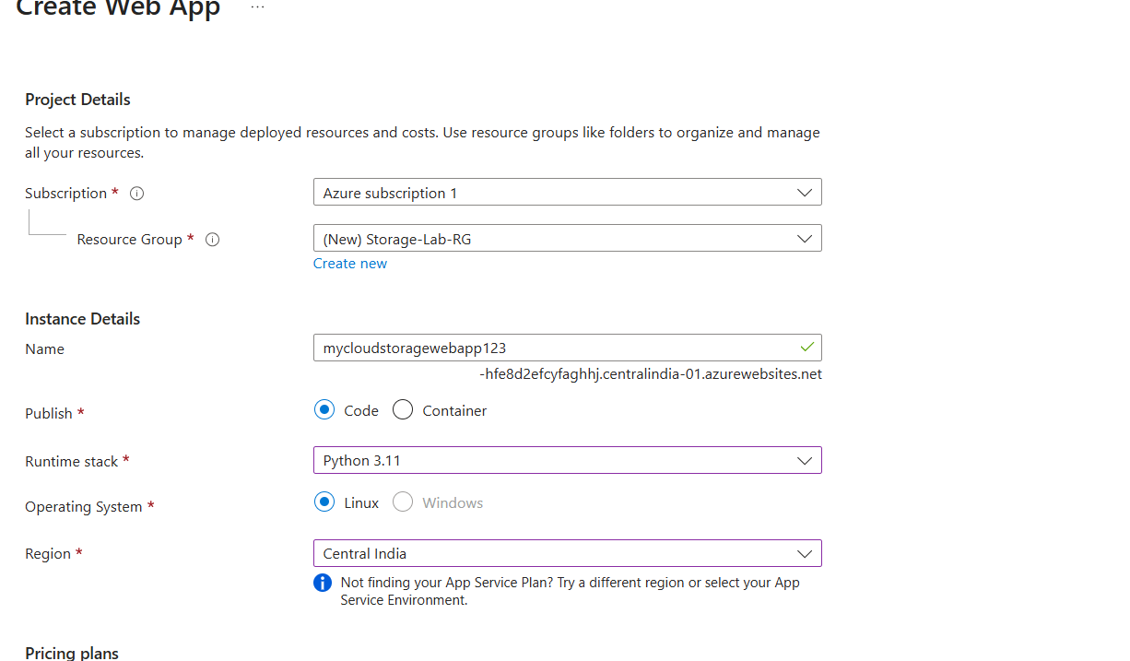
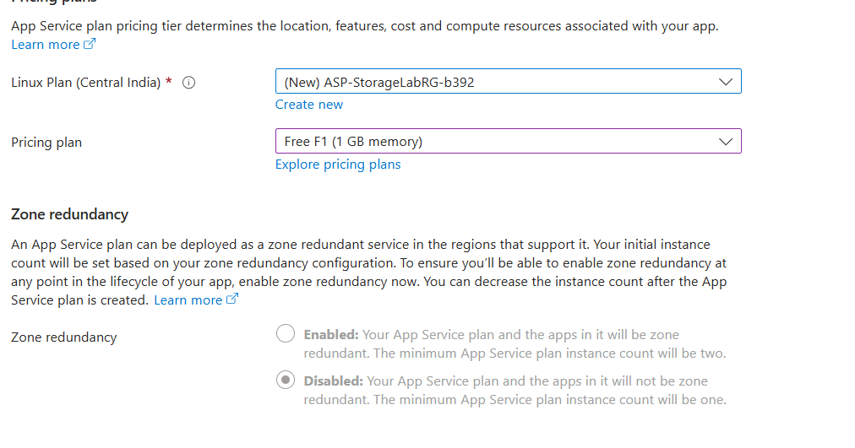

Step 2 Open the Web App
After deployment finishes, click:
Go to resource
On the Web App Overview page, you'll see:
Default domain like below then Click the URL.
You should see your web application.

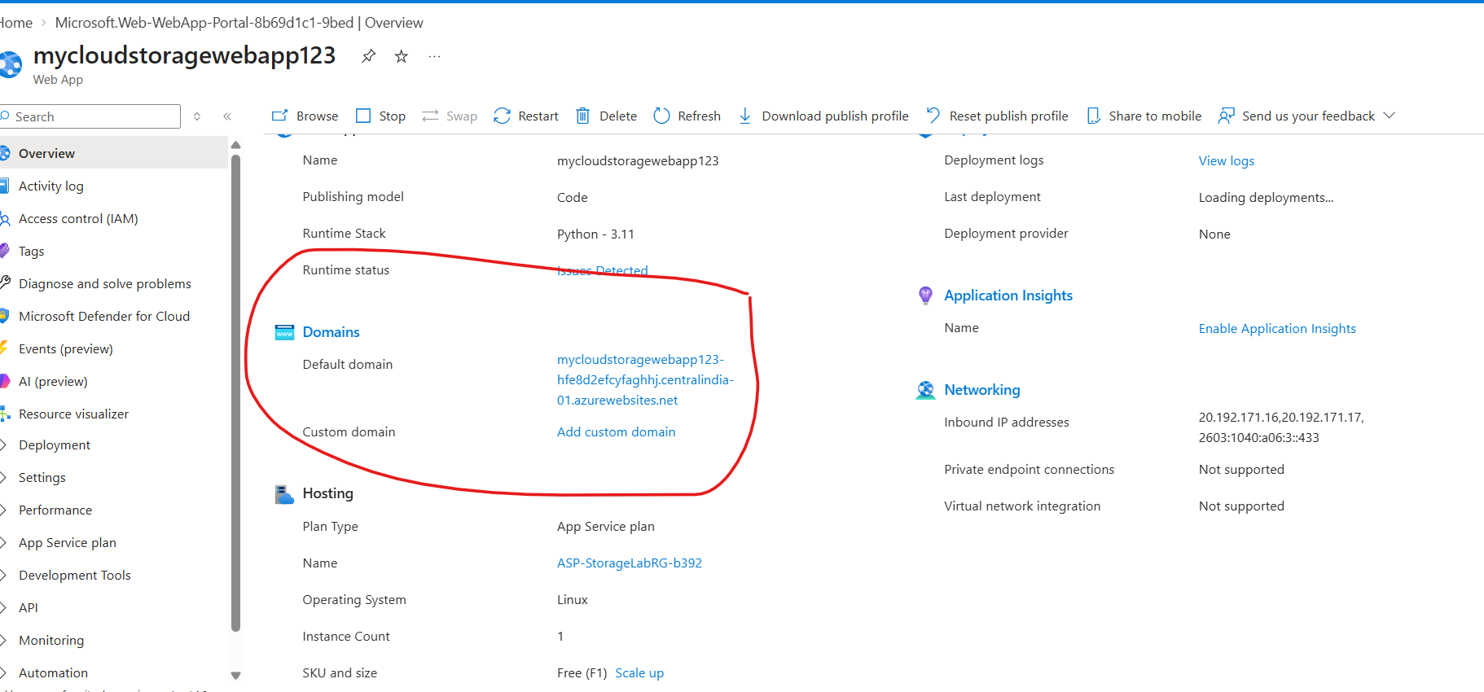

Step 3 — Create Azure Storage
In Azure Portal search:
Storage accounts
Click:
Storage accounts → + Create
Click crt resorce grp name>account name as I gave but change last 5 digit number as ur wish>storage blob storage >change redundancy to LRS
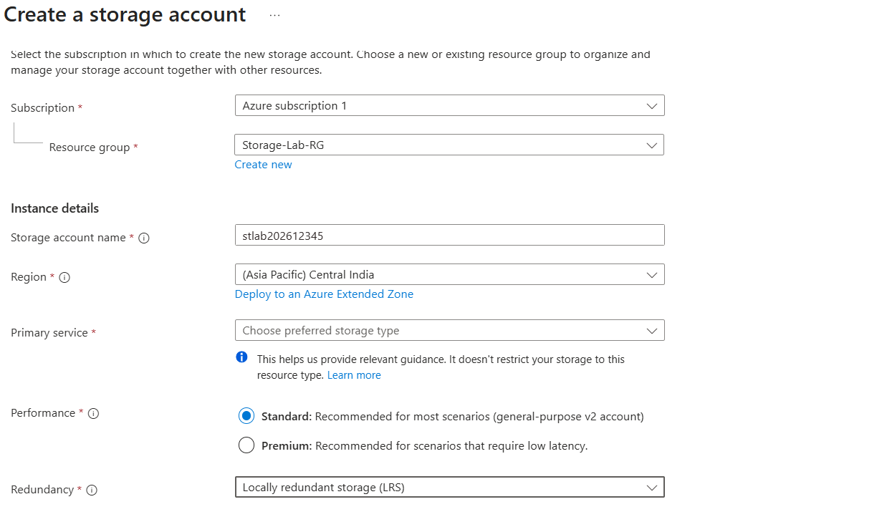
Click:
Review + create
Then:
Create
After creating type storage account n search box > click that
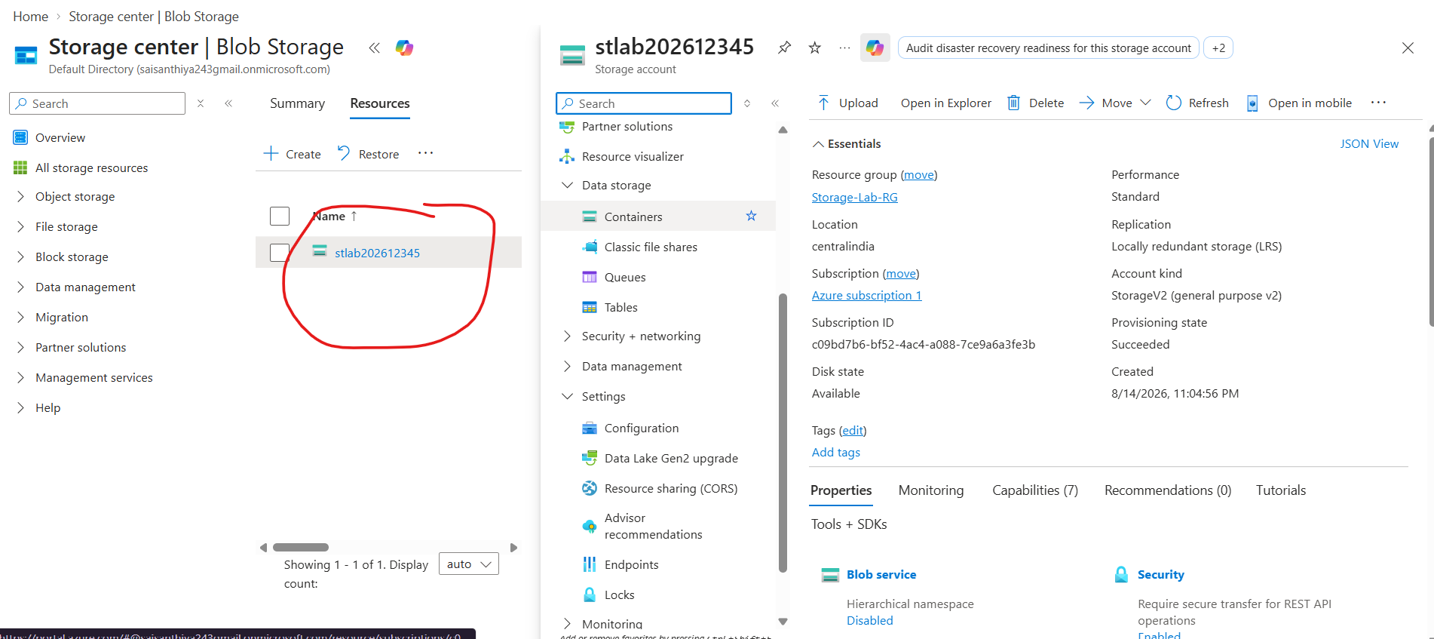
Follow 1 to 4
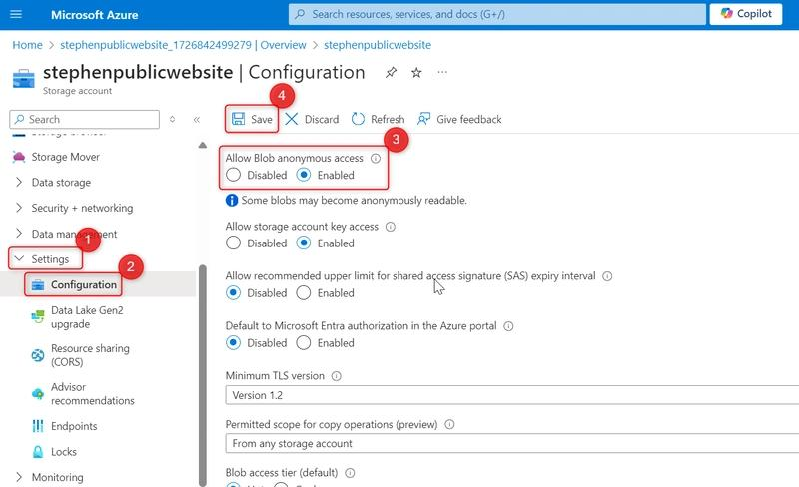

Step 4 Create a Container
Open your newly created Storage Account.
In the left menu find:
Data storage → Containers
Click:
+ Container>add container>give name as website > create

Step 5 Upload Your Web File
Open:
Containers → website
Click:
Upload
Create a simple HTML file on your computer, for example:
<!DOCTYPE html>
<html>
<head>
<title>Azure Cloud Storage Lab</title>
</head>
<body>
<h1>Welcome to Azure Storage</h1>
<p>This file is stored in Azure Blob Storage.</p>
<p>This demonstrates Storage as a Service.</p>
</body>
</html>
Save it as index.html>>>>important save correctly as index.html
Upload:
index.html
Click Upload.
Then Go to:
Data storage → Containers → website
Click:
Change access level
Now you should be able to select:
Blob (anonymous read access for blobs only)
Select Blob → OK.
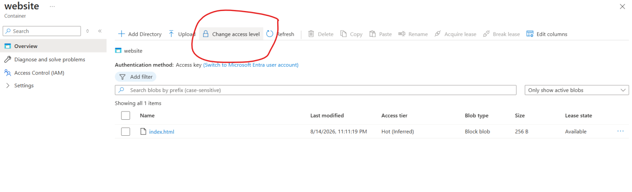

Step 6 Check Public Accessibility
Now click the uploaded:
index.html
You should find a:
URL / Blob URL
Copy the Blob URL.
Open a new Incognito/InPrivate window and paste the URL.
You should now see your HTML page like below
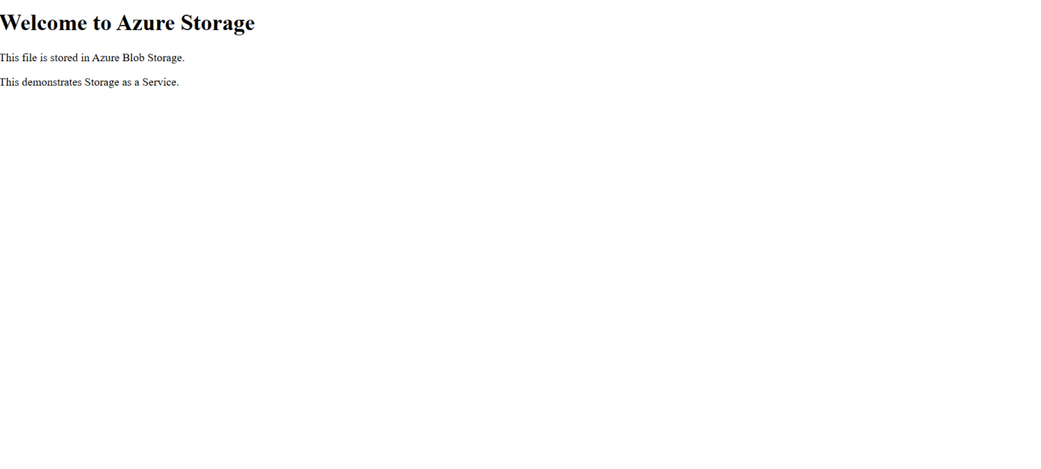
EXP 17
DEMONSTRATE INFRASTRUCTURE AS A SERVICE(IAAS) BY CREATING A VIRTUAL MACHINE USING A PUBLIC CLOUD SERVICE PROVIDER(AZURE/GCP/AWS) CONFIGURE WITH MINIMUM CPU, RAM AND STORAGE AND LAUNCH THE VM IMAGE.

STEP 1 — Sign in to Azure
Open:
Azure Portal
Sign in with your Azure account.

STEP 2 — Create Resource Group
Search:
Resource groups
Click:
+ Create

Basics
Enter:
Field | Value
Subscription | Your Azure subscription
Resource group | IaaS-Lab-RG (u can use existing one)
Region | Choose an available India region
For example:
Subscription: Your Azure subscription
Resource group: IaaS-Lab-RG
Region: Central India
Leave additional options at their defaults.
Click:
Review + create → Create

STEP 3 — Create Virtual Network
Search:
Virtual networks
Click:
+ Create

Basics
Field | Value
Subscription | Your Azure subscription
Resource group | IaaS-Lab-RG
Virtual network name | IaaS-Lab-VNet
Region | Same region as your VM
Click:
Next: IP addresses

IP addresses
Use:
IPv4 address space
10.0.0.0/16
Subnet:
Name: default
Subnet range: 10.0.0.0/24
Leave the other settings at their defaults.
Click:
Review + create → Create

STEP 4 — Create the Virtual Machine
Search:
Virtual machines
Click:
+ Create → Azure virtual machine

STEP 5 — Configure VM Basics
This is the most important screen.

Project details
Subscription:
Select your subscription.
Resource group:
IaaS-Lab-RG

Instance details
Virtual machine name:
IaaS-Windows-VM
Region:
Use the same region as your VNet.
Availability options:
For a basic lab, select:
No infrastructure redundancy required

STEP 6 — Select Windows VM Image
Under Image, select a Windows image.
For example:
Windows Server 2022 Datacenter: Azure Edition
If that exact image isn't available, select another available Windows Server image.

STEP 7 — Select Minimum CPU and RAM
Under:
Size
click:
See all sizes
You'll see different VM sizes.
For the experiment, choose the smallest suitable Windows VM size available in your region/subscription.
You may see something similar to:
B-series
2 vCPU
4 GiB RAM
or another small configuration.

Important
Don't choose a large VM.
minimum CPU, RAM and storage
So choose the smallest practical Windows VM size available to you.

STEP 8 — Administrator Account
Create the username and password you'll use to access the VM.
For example:
Username:
azureadmin
Create a strong password.
⚠️ Save the password somewhere secure.
You will need it when you open the RDP file.

STEP 9 — Configure Networking
Go to:
Networking

Virtual network
Select:
IaaS-Lab-VNet

Subnet
Select:
default

Public IP
Leave:
Create new

Public inbound ports
Select:
Allow selected ports
Then:
Select inbound ports → RDP (3389)
You don't need:
❌ HTTP
❌ HTTPS
❌ SSH
for this Windows/RDP experiment.

STEP 10 — Minimum Storage
Go to:
Disks
For a simple lab, leave the default OS disk configuration unless Azure allows you to select a smaller supported disk.
The important point is:
Do not unnecessarily increase the disk size.
For example, if Azure gives you a minimum/default OS disk around 30 GB, you can keep that rather than increasing it.
You don't need additional data disks.
So:
OS Disk: Default/minimum available
Data disks: None

STEP 11 — Review and Create
Click:
Review + create
Wait for:
Validation passed
Then click:
Create
Azure will deploy your VM.

STEP 12 — VM Deployment
Wait until you see:
Your deployment is complete
Click:
Go to resource
You should see your VM overview.
Something like:
IaaS-Windows-VM

Status: Running

Public IP address: xxx.xxx.xxx.xxx

Size: B-series/small VM
📸 Take a screenshot.
This demonstrates:
VM successfully deployed/launched.

STEP 13 — Connect to the Windows VM
On the VM Overview page, click:
Connect
Then:
RDP
Click:
Download RDP file
The .rdp file will be downloaded to your Windows computer.

STEP 14 — Open RDP
Go to:
Downloads
You'll see something similar to:
IaaS-Windows-VM.rdp
Double-click it.
Windows will show:
Remote Desktop Connection
Click:
Connect

STEP 15 — Enter Username and Password
Enter the administrator credentials you created earlier.
For example:
Username: azureadmin
Password: ********
Click:
OK / Connect
If Windows displays a certificate warning, verify that you're connecting to your newly created VM and proceed.

STEP 16 — Windows VM Desktop
After successful authentication, you should see the Windows desktop running inside Azure.
🎉 Your IaaS experiment is now successfully demonstrated.
📸 Take a screenshot of the remote Windows desktop.

Azure provides:
AZURE
│
Virtual Machine
│
┌───────────┼───────────┐
│ │ │
CPU RAM Storage
│ │ │
└───────────┼───────────┘
│
Windows OS
│
RDP
│
▼
Your Computer
This is IaaS because Azure provides the underlying infrastructure resources:
- Compute/CPU
- Memory/RAM
- Storage
- Networking
- Virtual machine infrastructure
while you control the operating system and applications.

NOTE : IN THIS DOCUMENT I COMPLETED EXPERIMENTS 12,13,15,17 AND THE EXPERIMENTS 14,16,18 ARE SIMILAR TO THE FOUR EXPERIMENTS OF THIS DOCUMENT …SO COMPLETE FROM 12 TO 18 AND UPLOAD SCREENSHOTS OR PDF N GITHUB AND NAME IT AS EXPERIMENT NUMBER

MOST IMPORTANT AFTER COMPLETING …DELETE ALL THE RESOURCE GROUPS USED FOR EXPERIMENTS 12 TO 18 …WHICH U CREATED N AZURE ACCOUNT LIKE BELOW …THAT S MANDATORY.
After taking screenshot TYPE RESOURSE GRP N SEARCH BAR AND delete the resourse grp like below
